# LeClair Group: Exclusive Products and Pricing

# Sr. Health Insurance Agencies

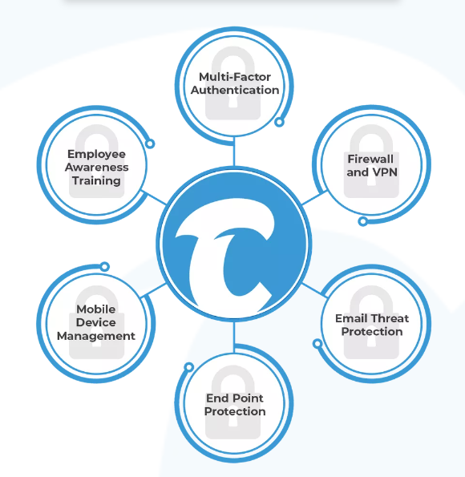

|  |  |  |  |
| --- | --- | --- | --- |
|  | **Starter** | **Standard** | **Elite** |
| PER USER | * Email Threat Protection * End Point Protection * Data Back Up of all files encrypted and off-domain | Everything in Starter PLUS   * Secure Internet (VPN) * Multi-Factor Authentication | Everything in Standard PLUS   * Mobile Device Management * Encrypted Outbound E-mail |
| PER FIELD OFFICE |  |  | * Next-Gen Firewall Hardware * Server Protection * Firewall Management |
| PER AGENCY | * 24 x 7 Security Team + Threat Hunting * Zero-Cost Remediation | * Information Security and Response Planning (ISP/WISP) * Identity and Business Fraud Restoration * Regulatory Response and Client Notification – Data Breach |  |
| STANDARD PRICING MSRP | $55 per user | $80 per user  $180 per agency | $115 per user  $225 per office  $180 per agency |
| **LECLAIR EXCLUSIVE PRICING** | **$39 per user** | **$50 per user**  **$70 per agency** | **$80 per user**  **$200 per office**  **$70 per agency** |

**Added Value for Agencies without O365 or Google Workspace e-mail: Domain and Professional E-mail Setup $100 one-time fee (50% off)**

**CyberFin Product Levels**

**Starter**

* 1–3-person agency or multiple independent reps (1099) adding multi-layered security to their agency
* They do not store documents locally.
* All in CRM’s or IMO/Carrier cloud sites.
* DOES NOT have a field office
* Does business primarily in one or two states

**Standard**

* Small to medium sized agency(s) that provide Life Insurance, Individual Health, Group Health and Annuities would need to be as secure and compliant as possible.
* Store documents locally in the cloud or in a File Explorer (SharePoint, One-Drive, Google drive)
* DOES NOT have a field office or only small team (10 or less) works there regularly with no guest wifi.
* Does business in multiple states.

**Elite**

* What all small to medium sized agency(s) that provide Life Insurance, Individual Health, Group Health and Annuities would need to be as secure and compliant as possible.
* They store documents locally in a physical/virtual server owned by the agency.
* Team is not disciplined enough to manually turn on encryption of e-mails.
* Multiple producers using smart phones to interact with customer data (CRM, AMS, Text, Mail)